**GENETICS PRACTICE QUESTIONS**

**Please note there are many practice questions spread throughout the genetics lecture notes. Try those too!**

1. In corn, the *colour* gene has two alleles, *C1* and *C2. C1* is dominant to *C2* and results in yellow kernels. The *starch* gene also has two alleles, *S1* and *S2*, and *S1* is dominant to *S2* and results in highly starchy corn. Finally, the *wax* gene also has two alleles, *W1* and *W2*. These three genes are on three different chromosomes.
2. A corn plant has the genotype *C1/C2; S1/S2; W1/W2*, as shown in the diagram below.

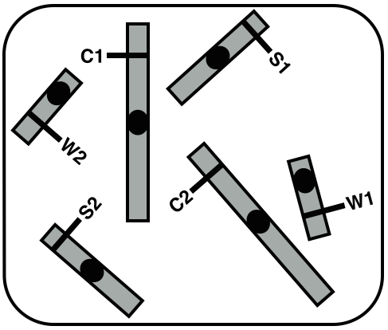

What is the maximum number of different gamete genotypes that can be produced when a single sex cell from this plant undergoes meiosis? (1 mark)

4 (four)

1. A sex cell from this corn plant undergoes meiosis and produces four gametes. Two of these four gamtes are represented in the diagrams below:

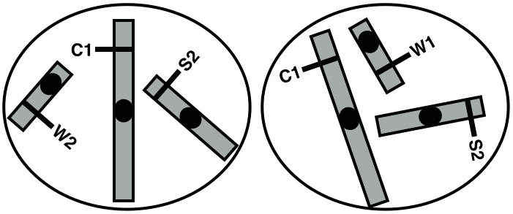

Based on the gametes show above, draw clear diagrams showing the chromosomes of the original corn sex cell that produced these two gametes:

1. at G2 (after DNA replication, before the start of meiosis): (4 marks)

* Must have right number of chromosomes
* Chromosomes must have sister chromatids, clearly attached to each other and relatively parallel to each other
* Homologs need to look homologous enough
* Sister chromatids must have identical alleles (if only one allele indicated, they must clearly show the “line” that spans both chromatids)

Example:

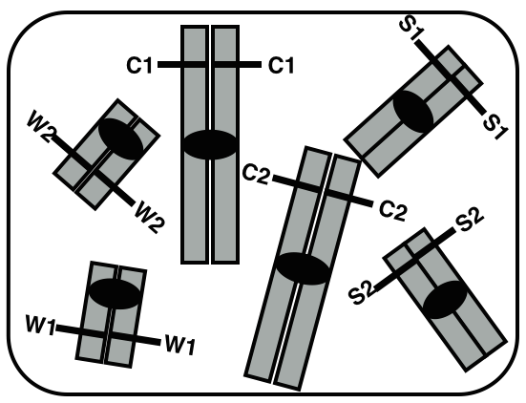

1. at metaphase of meiosis I, clearly indicating the direction in which the chromosomes will segregate/move: (4 marks)

* homologs have to be paired
* pairs have to be lined up head to tail
* direction of segregation has to be clear and result in C1;S2 and C2;S1 gametes
* there has to be evidence of crossing over somewhere between the W gene and the centromere of the chromosome it is on, involving two non-sister chromatids (see diagrams for examples)

(note: this example has arrows that show the direction of segregation, but if the diagram is clear, it is OK for students not to draw the arrows-e.g. markers will assume that all the “up” chromosomes will go “up”)

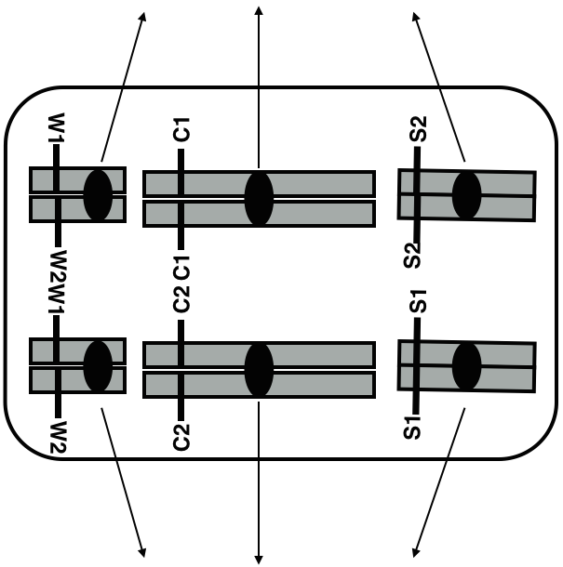 OR

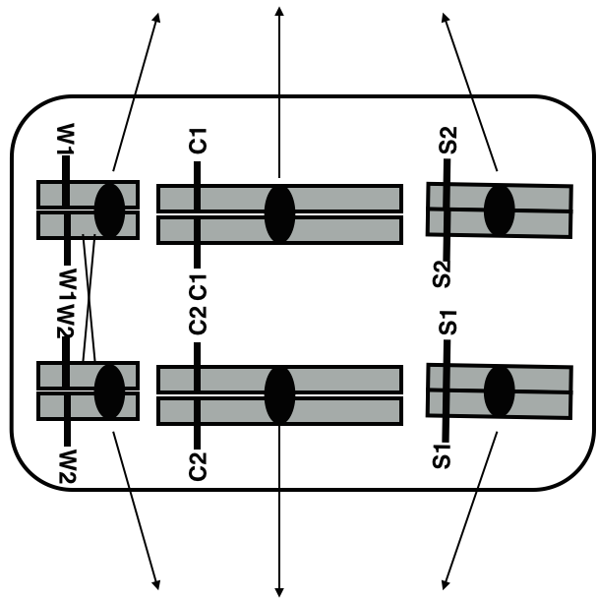

***Yes, this horn shape is about unicorns. It is a ridiculously fake example. The purpose is to practice your genetic analysis skills.***

You have been hired to investigate the inheritance of horn shape and ear shape in unicorns. Two horn shape phenotypes exist in nature: smooth (the wild-type) and spiral (rare, mutant). For ear shapes there are three known phenotypes: pointy (the wild-type), round (rare, mutant) and blunt (also rare, mutant). Under optimal laboratory conditions, unicorns can produce large litter of about 16 babies.

a) You first focus on horn shape. Under controlled laboratory conditions you set up three crosses (1-3) using six different parent unicorns in total. The results are as follows:

Cross # Parent unicorns F1

1. smooth horn X spiral horn 100% have spiral horn

2. smooth horn X spiral horn 50% have spiral horn

50% have smooth horn

3. spiral horn X spiral horn 75% have spiral horn

25% have smooth horn

i) Define the letters or symbols that you use to denote your alleles, then complete the table by assigning genotypes to each of the parent and F1 unicorns from cross 3. (6 marks)

H1 = smooth (0.5 mark)

H2 = spiral (0.5 mark)

(they can define the allele in any way, but they need to be consistent throughout)

|  |  |
| --- | --- |
| **Unicorns** | **Genotypes** |
| First spiral horn parent in cross 3: | H1/H2 |
| Second spiral horn parent in cross 3: | H1/H2 |
| Spiral horn F1 unicorns in cross 3: | H1/H2 and H2/H2 |
| Smooth horn F1 unicorns in cross 3: | H1/H1 |

ii) What is the dominance relationship between the smooth and spiral horn *phenotypes.* Explain your answers and specifically refer to the data to support your view. (4 marks)

The spiral horn phenotype is dominant to the smooth horn phenotype (1 mark),

as heterozygotes H1/H2 have spiral horns, like homozygotes H2/H2.

(2 marks) 1 mark for each of two pieces of evidence (e.g. all of cross 1 are spiral;   
or only 25% of the cross between two heterozygotes are smooth)

(1 mark) for explaining WHY the evidence demonstrates dominance (e.g. a individual with both alleles is the same phenotype as the spiral homozygote so it is dominant;  
or you need two smooth alleles to be smooth, so it is recessive)

The point becomes, how do we know that homozygotes H2/H2 and heterozygotes are spiral:

* In cross 1, only one parent has spiral horn and the other has a smooth horn, but all the F1 individuals have a spiral horn, like one of their parents, suggesting that the two phenotypes have a simple dominant/recessive relationship and that spiral is dominant to smooth.

(continued on next page)

* We know that heterozygotes have spiral horns by looking at cross 3 (for example): some of the F1 unicorns have smooth horns, meaning that they need to inherit the allele from smooth from at least one of the parents, so we know that at least one of the parents must have the allele for smooth. We also know that both parents must have at least one allele for spiral, since they have spiral horns. So, at least one parent must be heterozygous, yet its phenotype is spiral, suggesting that spiral is dominant to smooth.
* This hypothesis is confirmed in cross 2, where he spiral horn parent is likely a heterozygote, the smooth horn parent is homozygous recessive, and the F1 unicorns show a 1:1 ratio of the two phenotypes.

b) You then go on to investigate the inheritance of ear shape by performing five more crosses (4-8) in the lab. The results are reported below.

Cross # Parent unicorns F1

4. pointy ears X pointy ears 100% have pointy ears

5. pointy ears X round ears 100% have blunt ears

6. round ears X round ears 100% have round ears

7. blunt ears X blunt ears 50% have blunt ears,

25% have pointy ears,

25% have round ears

8. round ears X blunt ears 50% have round ears,

50% have blunt ears

i) Define the letters and numbers you use for each allele, then fill out the table below by assigning genotypes to each of the unicorns listed. (5 marks)

e.g. Alleles: E1 (pointy) and E2 (round)

|  |  |
| --- | --- |
| **Unicorns** | **Genotypes** |
| Pointy ears parent in cross 5: | E1/E1 |
| Round ears parent in cross 5: | E2/E2 |
| Blunt ears F1 unicorns in cross 5: | E1/E2 |
| Round ears parent in cross 8: | E2/E2 |
| Blunt ears F1 unicorns in cross 8: | E1/E2 |

ii) What are the dominance relationships among *the alleles* that you defined in part i)? Explain your answers and specifically refer to the data to support your view. (4 marks)

E1 is neither dominant nor recessive to E2 (1 mark); the data are consistent with heterozygotes E1/E2 having blunt ears (1 mark).

E.g. explanation (2 marks): When crossing two blunt ears individuals, we obtain an F1 with a 1:2:1 ratio of round:blunt:pointy ears, which is what we would expect if E1/E2 gives blunt ears, E1/E1 pointy and E2/E2 round.

Similarly, crosses between round and pointy ears parents produce F1s with a phenotype that is different from both parents, which is typical of situations where alleles are neither dominant nor recessive to each other.

Also, round ears and pointy ears always seem to be pure breeding (see crosses 4 and 6), while blunt ears are never pure-breeding (see crosses 5 and 8), which is also consistent with the explanation above.

c) In a further investigation you set up a cross between two unicorns homozygous for both traits; one has a spiral horn and pointy ears and the other has a smooth horn and round ears. You then take males and females F1 individuals from this cross and mate them together to obtain a F2. What are the expected phenotypes and their proportions in this F2? Show all your work for full credit. (6 marks)

H2/H2 . E1/E1 X H1/H1 . E2/E2

F1: 100% H2/H1 . E1/E2

Gametes produced by F1 individuals (expected):

25% H2 . E1 (2 marks for the gametes from the F1 cross)

25% H2 . E2

25% H1 . E1

25% H1 . E2

Expected F2: (2 marks for the combination of gametes)

|  |  |  |  |  |
| --- | --- | --- | --- | --- |
|  | H2 E1 25% | H2 E2 25% | H1 E1 25% | H1 E2 25% |
| H2 E1 25% | H2/H2 E1/E1  6.25%  spiral pointy | H2/H2 E2/E1  6.25%  spiral blunt | H2/H1 E1/E1  6.25%  spiral pointy | H2/H1 E1/E2  6.25%  spiral blunt |
| H2 E2 25% | H2/H2 E1/E2  6.25%  spiral blunt | H2/H2 E2/E2  6.25%  spiral round | H2/H1 E2/E1  6.25%  spiral blunt | H2/H1 E2/E2  6.25%  spiral round |
| H1 E1 25% | H2/H1 E1/E1  6.25%  spiral pointy | H1/H2 E1/E2  6.25%  spiral blunt | H1/H1 E1/E1  6.25%  smooth pointy | H1/H1 E1/E2  6.25%  smooth blunt |
| H1 E2 25% | H2/H1 E1/E2  6.25%  spiral blunt | H2/H2 E2/E2  6.25%  spiral round | H1/H1 E1/E2  6.25%  smooth blunt | H1/H1 E2/E2  6.25%  smooth round |

TOTALS: Spiral blunt: 37.5% = 6/16 (2 marks for the ratio of phenotypes)

Spiral pointy: 18.75% = 3/16

Spiral round: 18.75% = 3/16

Smooth blunt: 12.5%= 2/16

Smooth pointy: 6.25%= 1/16

Smooth round: 6.25% = 1/16

1. For this pedigree, determine the mode of inheritance and the possible genotypes for each individual. Assume the alleles B1 and B2 control the expression of the trait.   
   **(16 marks total)**

1

2

3

4

5

6

7

8

9

10

11

12

13

14

15

16

17

|  |  |  |
| --- | --- | --- |
|  | Possible or impossible? | **If impossible:** provide support for your answer making specific reference to the relevant individuals in the pedigree. |
| Autosomal dominant | *Possible*  *(1 mark)* | *None required.* |
| Autosomal recessive | *Impossible*  *(1 mark)* | *If both 7 and 8 are affected, they would both be [bb], their daughter 10, would also have to be [bb] and so should be affected. (****2 marks, 1 for the individuals involved and 1 for the explanation****) No marks for skips a generation.* |
| X-linked dominant | *Impossible*  *(1 mark)* | *13 is an affected male, so he would be XB/Y, he would pass his X chromosome on to his daughters, but none of them are affected. (****2 marks, 1 for the individuals involved and 1 for the explanation****) No marks for equal # of males and females as an explanation* |
| X-linked recessive | *Impossible*  *(1 mark)* | *3 is an affected female, so she would be Xb/Xb, she would pass one of her X chromosomes on to her sons, so they would both be Xb/Y and affected, but 9 is not.* ***(2 marks, 1 for the individuals involved and 1 for the explanation****) No marks for equal # of males and females as an explanation* |

**b.** Define which of the two alleles (B1 or B2) is the dominant allele.

Give the possible genotype/s for the following individuals: **(3 marks)**

***0.5 marks for each, all or nothing for each individual number***

3 __Bb___ 6 ___bb___ 8 __Bb___

10 ___bb___ 11 BB or Bb 13 __Bb___

OR

3 __B1B2___ 6 ___B2B2___ 8 __B1B2___

10 __B2B2__ 11 B1B1 or B1B2 13 __B1B2___

**c.** If individuals 13 and 14 have a 4th child, what is the probability that it will be an affected son? State the genotypes of both parents and the child. **(3 marks)**

*Dad 13 has to be a* ***Bb*** *(because he has unaffected daughters) and Mom 14 has to be* ***bb****.*

*(****1 mark****)*

*There’s a ½ chance (or 0.5 probability) that it will be a son (****0.5 mark****) and a ½ chance (or 0.5 probability) that it will be affected (****0.5 mark****). So ½ x ½ = ¼ chance it will be an affected son. (****1 mark****)*

***4.*** The image on the right shows all 68 chromosomes from one root tip cell of a plant called *Campanula rotundifolia* after DNA replication.



1. How many chromatids does one of these chromosomes have?

*2 chromatids.*

b) How many DNA double helices is each one of chromosomes made of? (1 mark)

*2*

1. It is very difficult to recognize homologous chromosomes on the picture, but knowing that *Campanula rotundifolia* is diploid, how many pairs of homologous chromosomes are present in one of its root tip cells? (1 mark)

*34*

5. Ben and Todd are brothers. Todd has a tendency to speak very loudly on his cell phone on the bus (we’ll call this phenotype “annoying loud talker”. Ben talks very quietly on his cell phone on the bus (“not annoying”). A geneticist wonders if this trait is genetic. He compares the genome sequences of Ben and Todd, looking for differences in sequences known to be involved in two behaviours: 1) voice volume, and 2) self-consciousness.

1. Propose at least 3 different possible results of the sequence comparisons that might suggest that “annoying loud talking” is a genetic trait? Note that you can make wild assumptions about gene function if that helps in your explanation (although it is not necessary).

*There may be other logical ideas, these are just three:*

1. *Change in a gene that results in different gene function. (could be in either twin, depending on the function of the gene)*
2. *Change in a gene that results in no gene function (could be in either twin, depending on the function of the gene)*
3. *Change in a non-gene region, something that affects expression of a gene.*
4. Upon completing the DNA sequence comparison they find that Ben and Todd do not have any different alleles of the genes involved in voice volume or self-consciousness. However, they do notice that Todd has three copies of a gene involved in a *lack* of self-consciousness. Why is this unusual, and how could these three gene copies explain his “annoying loud talker” phenotype?

*Diploid, should only have two copies.*

*More expression of a gene results in a greater lack of self-consciousness compared to Ben, so he talks louder on the bus (doesn’t care what other people think).*

**6.** In hogs, a dominant allele *B* results in a white belt around the body (phenotype is called belted) and *b* results in unbelted. At a separate locus the dominant allele *S* causes fusion of the two parts of the normally cloven hoof resulting in a condition known as syndactyly, and the recessive allele, *s*, causes hoofs to be cloven.

1. Summarize what you know about the genes and alleles (dominance relationships), by clearly defining genes and alleles:

*B – belted > b – unbelted*

*S – syndactyly > s - cloven*

1. A belted syndactylous female was crossed to an unbelted cloven-hoofed male, and in the litter there were:

Normal tips we give: designate symbols for each allele (better not to use capital and small letters when you are still trying to figure out dominance) Help them figure out what information they know from the question and what are they trying to find out. Help them think about what different possible F1 ratios mean.

18 belted syndactylous

21 belted cloven

19 unbelted syndactylous

20 unbelted cloven

Analyze the offspring phenotypes and proportions. What are the genotypes of the parents and offspring? Show all of your work, especially the work you have done to prove that your predicted parent genotypes can give the offspring phenotypes and proportions above.

*1:1:1:1 ratio suggests that a heterozygote was crossed to a homozygote.*

*Belted syndactylous female, possible genotypes.*

*B/_; S/_*

*Unbelted, cloven male, possible genotypes:*

*b/b; s/s*

*Must be homozygous for both recessive alleles in order to be unbelted and cloven*

*If the female was: B/b; S/s x b/b; s/s*

*Possible female gametes and proportions expected:*

|  |  |  |  |  |
| --- | --- | --- | --- | --- |
|  | *BS ¼ (25%)* | *Bs ¼ (25%)* | *bS ¼ (25%)* | *Bs ¼ (25%)* |
| *Male gametes are all:*  *b; s* | *B/b; S/s*  *Belted, syndactylous* | *B/b; s/s*  *Belted, cloven* | *b/b; S/s*  *unbelted, syndactylous* | *b/b; s/s*  *unbelted, cloven* |

*This result matches what we were given, suggesting that the parental genotypes I came up with are likely correct.*

c.       From the offspring given in part b, if two belted syndactylous animals were mated, what would you expect if there were 112 F2s? (phenotypes and number of each)

*B/b; S/s x B/b; S/s*

*Draw a Punnett Square.*

*B/_;S/_ 9/16 *112 63 belted syndactylous*

*b/b; S/_ 3/16 * 112 21 unbelted and syndactylous*

*B/_; s/s 3/16*112 21 belted and cloven*

*b/b; s/s 1/16*112 7 unbelted and cloven*

1. Now imagine that the B and S genes were very close together on the same chromosome, such that no crossing over happens between them. You have two heterozygotes, as in part c, that mate and generate 112 F2. If one of the heterozygotes is BS/bs and the other is Bs/bS how do you expect the F2 phenotype numbers to change?

*Gametes from BS/bs individual:*

|  |  |  |  |
| --- | --- | --- | --- |
|  |  | *BS ½ (50%)* | *bs ½ (50%)* |
| *Gametes from the Bs/bS individual* | *Bs ½ (50%)* | *¼ BS/Bs*  *Belted syndactylous* | *¼ bs/Bs*  *belted cloven* |
| *bS ½ (50%)* | *¼ BS/bS*  *Belted syndactylous* | *¼ bs/bS*  *unbelted syndactylous* |

*So:*

*¼ *112= 28*

*56 belted syndactylous*

*28 belted cloven*

*28 unbelted syndactylous*

**7.** In a maternity ward, four babies become accidentally mixed up. The ABO phenotypes of the four babies are known to be:  baby #1 O, baby #2 A, baby #3 B, and baby #4 AB. The ABO phenotypes of the four sets of parents are:

Parents:

(a) AB × O

(b) A × O

(c) A × AB

(d) O × O

a.     Analyze this information to predict which parental set (a-d) could be the parents of each baby.  Show your work, and then complete the table below.  Use the following symbols for alleles:

O – iO, A – iA, B – iB, remember that the dominance relationship is A>O, B>O, A and B are not dominant to one another (blended/see both)

|  |  |  |
| --- | --- | --- |
| Phenotype | Genotype or possible genotypes | Possible parental set(s): |
| Baby #1 - O | *iO/iO,* | *b (if A is heterozygote, iA/iO) or d* |
| #2 – A | *iA/iA, iA/iO* | *a, b* |
| #3 – B | *iB/iB, iB/iO* | *A, c (if A is iA/iO)* |
| #4 - AB | *iA/iB* | *c* |

c.     Draw a cell from an AB parent before DNA replication, after DNA replication, and in metaphase of meiosis I (homologous chromosomes lined up to separate).  Label chromosomes with alleles, chromatids, homologous pairs.  What are the resulting gamete genotypes, and in what proportions, from this meiotic division?

*Half will be iA, half will be iB.*

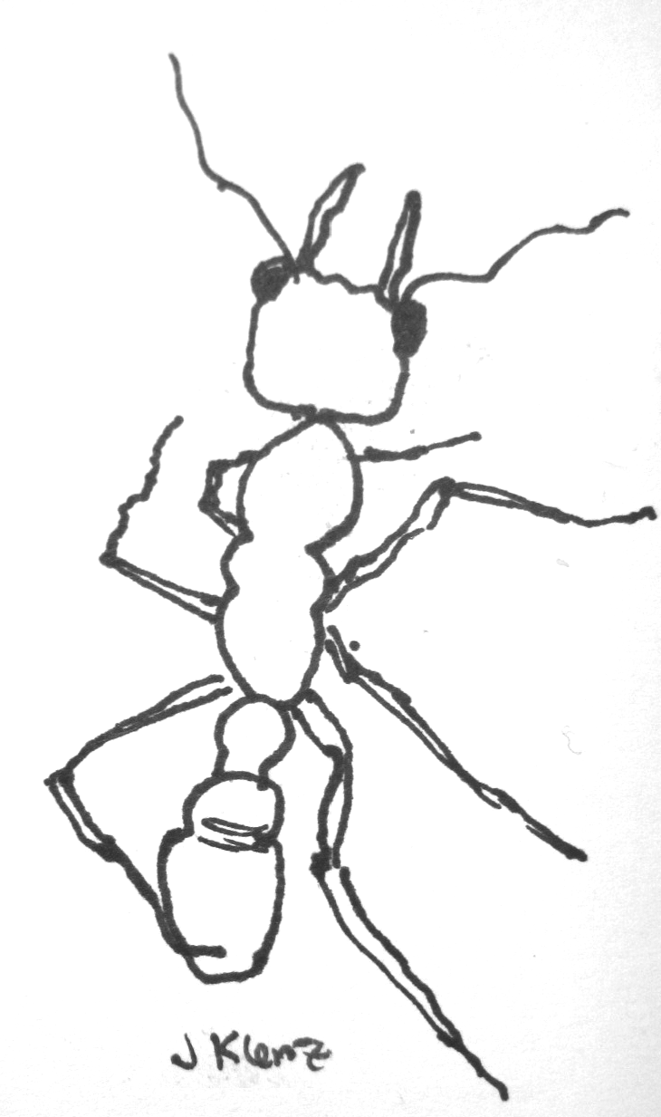

**8.** The jack jumper ant (*Myrmecia pilosula)* is 2n = 2. An ant has the genotype *aB/Ab* (the A and B loci are on the same chromosome). It was produced from two pure-breeding parents with the genotypes *aB/aB* and *Ab/Ab* respectively.

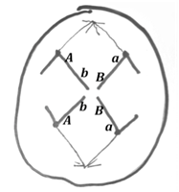i) Based on the structures separating in this figure to the left, what stage of **meiosis** is cell this.

*Remember it says MEIOSIS! So what stage could it be in meiosis?*

*Sister chromatids are separating, so that is anaphase of meiosis II.*

1. Given your answer to part i, and knowing that the genotype of our 2n=2 jack jumper ant, what is incorrect about this cell, and what, if anything is correct.

Now that they have decided on the stage then explain how it deviates.

If sister chromatids are separating the products from this part of meiosis will be two of the four gametes. The gametes from what is shown below will be 2n=2, which is wrong. They should be n=1. So there are too many chromatids here.

The allele combinations are correct (aB from one parent, and Ab from another parent)

b) For the stage shown in a) draw what the meiotic cell SHOULD correctly look like for the ant described above. (3 marks)



**9.** The ability to taste the chemical phenylthiocarbamide is an autosomal dominant phenotype, and the inability to taste it is recessive. A taster woman with a non-taster father marries a taster man who, in a previous marriage, had a non-taster daughter. The taster man and woman are going to have a child. What are the possible genotypes and phenotypes, including probabilities, of their child?

*T – taster, t – non-taster, T>t*

*Woman must be T/t (T because she’s a taster, t because she got that from her non-taster father, who must have been t/t)*

*Man must be T/t* *(T because he’s a taster, t because he would have to have a t in order to create a homozygous t/t nontaster daughter)*

*So, the man and woman having children are: T/t x T/t*

*¼ will be T/T taster*

*½ will be T/t taster*

*¼ will be t/t non taster*

*So, ¾ will be taster, ¼ will be nontaster*

**10.** Loppins (*Loppinicus loopy*) are fictitious, but very useful diploid invertebrates with a total of 6 chromosomes in their somatic cells. Of those 6 chromosomes, 4 are autosomes and 2 are sex chromosomes. Like humans, male loppins are XY while females are XX.

The gene that determines loppins’ blood type is called *bt* and is on chromosome 1, the gene that determines the presence or absence of eyelashes is called *eye* and is on chromosome 2, and the gene that determines ability to digest cellulose is called *cel* and is on the X chromosome.

*btA, btB; eyeW, eyeD, celWT* and *celM* are alleles of these three genes.

1. A female loppin is a triple heterozygous with the genotype *btA/btB; eyeWT/eyeD;* X*celWT*/X*celM*.

Her mother was homozygous for *btA,* for *eyeD* and for *celWT*.

Draw a somatic cell of our triple heterozygous female loppin in G1 stage of the cell cycle (that is, before DNA replication). Make sure that the chromosomes are properly drawn and clearly label all the relevant genes and alleles. **(4 marks)**

-pay attention to whether the students have created 3 chromosomes that are distinctly different from each other

1. What alleles did the triple heterozygous female loppin inherit from her mother, and what alleles did she inherit from her father? **(2 marks)**

-this is practice with the problem-solving skills that Craig started doing on Friday. And you can tell them my rule which is the “Its gotta come from somewhere” rule. They were told the genotype of the mother so that allows them to determine the alleles from the mother. What’s left has to come from the father.

1. For research purposes you remove three meiocytes from the triple heterozygous female, you let them undergo meiosis, and you analyze the genotype of the gametes that are produced. The first meiocyte produces two gametes of genotype *btA; eyeWT;* X*celWT* and two gametes of genotype *btB; eyeD;* X*celM*.

i) Draw this meiocyte at metaphase of meiosis I (this is when the homologous chromosomes are paired and lined up in the centre of the cell). Make sure to clearly label all the relevant genes and alleles. **(3 marks)**

-remind the students that how the chromosomes line up at metaphase I is what sets up the whole pattern of segregation for creating the gametes.

1. The second meiocyte produces two gametes of genotype *btB; eyeWT;* X*celWT* and two gametes of genotype *btA; eyeD;* X*celM*. Explain what must have happened differently in this meiocyte compared to the one in part i) to produce this result. You may refer to the diagram that you drew above to illustrate your rationale. **(1 mark)**

A different arrangement of the chromosomes at metaphase I.

1. If we looked at the gametes produced by 100 different meiocytes from this triple heterozygous female loppin, what are all the genotypes that we would expect to find, and in what proportions? *(Note: 100 different meiocytes will produce a total of 400 gametes)*

As each gene is on a different chromosome then everything is assorting independently so each type of gamete is equally likely. They should be able to come up with all the combinations without too much difficulty.

1. ABO blood type in mice is similar to that in humans where there are 3 alleles of the I gene: IA = IB > i, where the first two alleles are co-dominant to each other and both are dominant to the recessive i allele (when homozygous results in blood type O). Two mutant mice of blood type AB are obtained from the same litter and mated.
2. What are the expected results obtained from repeated crosses of these two mice in terms of ABO blood types?

***3 marks****:*

*¼ IA/IA =bloodtype A*

*½ IA/IB = bloodtype AB*

*¼ IB/IB = bloodtype B*

1. **A tough one!**

Repeated crosses between the two mice, each with blood type AB, gave the following phenotypic ratios of:

3/16 type A

4/16 type O

3/16 type B

6/16 type AB

Based on your analysis of the data provide a detailed explanation for the resulting phenotypes and ratios observed in the progeny of the cross including complete genotypes of both the original parents and their progeny. Show your work.

*for recognizing that this is a modified dihybrid ratio meaning that they must be two genes involved They can state that the data in b totals to 16 so there are two genes at work.*

*They can use a Punnett square or branched diagram or something else where they indicate the probabilities of each type of offspring*

*Eg*

|  |  |  |
| --- | --- | --- |
|  | *½ A* | *½ B* |
| *½ A* | *¼ A/A* | *¼ A/B* |
| *½ B* | *¼ A/B* | *¼ B/B* |

|  |  |  |
| --- | --- | --- |
|  | *½ Q* | *½q* |
| *½ Q* | *¼ Q/Q* | *¼ Q/q* |
| *½ q* | *¼ Q/q* | *¼ q/q* |

***OR***

|  |  |  |  |  |
| --- | --- | --- | --- | --- |
|  | ***¼ A Q*** | ***¼ A q*** | ***¼ B Q*** | ***¼ B q*** |
| ***¼ A Q*** | ***1/16 A/A; Q/Q*** | ***1/16 A/A; Q/q*** | ***1/16 A/B; Q/Q*** | ***1/16 A/B; Q/q*** |
| ***¼ A q*** | ***1/16 A/A; Q/q*** | ***1/16 A/A; q/q*** | ***1/16 A/B; Q/q*** | ***1/16 A/B q/q*** |
| ***¼ B Q*** | ***1/16 A/B; Q/Q*** | ***1/16 A/B; Q/q*** | ***1/16 B/B; Q/Q*** | ***1/16 B/B; Q/q*** |
| ***¼ Bq*** | ***1/16 A/B; Q/q*** | ***1/16 A/B q/q*** | ***1/16 B/B; Q/q*** | ***1/16 B/B; q/q*** |

***A blood type B blood type AB blood type O bloodtype***

*for calculating the probability of each bloodtype that matches with the data in the question. They can use Punnett Squares or do the calculation.*

*1/4 A/A x ¾ Q/_ = 3/16 Bloodtype A*

*½ A/B x ¾ Q/_ = 6/16 Bloodtype AB*

*¼ b/B x ¾ Q/q = 3/16 Bloodtype B*

*1 _/_ x ¼ q/q = 4/16 bloodtype O*

*for somehow explaining how Blood type O is observed due to the recessive homozygote of the second gene q/q prevents either the IA or IB allele from being expressed or detected on blood cells*

1. A mutant allele in mice causes a big ears. Six pairs of mice were crossed. Their phenotypes and those of their progeny are given in the following table. N is normal phenotype; B is big ears phenotype. The symbol with the upward arrow is male, the symbol with the circle and + is female.

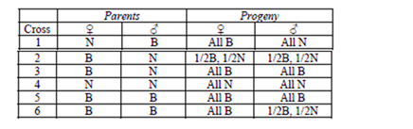

1. What is your hypothesis about the inheritance of the big ears trait (mode of inheritance, dominance relationships). Explain what data you have used to formulate this hypothesis. Be sure to define gene and allele symbols.

*X-linked. Differences in male and female offspring phenotypes suggests X-linkage.*

*Big ears is dominant to normal. If we look at cross #1 we see that all the females are big eared, despite the fact that the females would inherit an X-chromosome from the female parent, which would carry a normal (N) allele.*

1. What is the genotype of the parent mice for cross #6?

*Half and half in the male offspring suggests the female parent was a heterozygote: XB/XN, and the male parent was XB/Y.*

1. If you only had cross 2 would you have come to the same conclusion? Explain.

*That it could be autosomal, and the big eared parent was heterozygous, and the normal parent is homozygous.*